Final Project

Michael Woodmansee

# Overview

My final project I will be creating a windows program the will upload an image and tell the user if and how it was modified.

# Goals

1. Creation of the program (base program, but no working detector)
2. The creation of an image modification detector (Failed )
3. Creating 10 fake images and get 10 real images to run through the program (Done )
4. Learning to push visual studio projects to github. (Done)

# Specifications

* For this project I will be using visual studio 2019 , for building the windows program.
* For documentation i will be using Google docs and slides.
* All project file will be hosted on GitHub under a private repository.
* I will be following an agile programming method and will be testing the program with every iteration.

# Milestones

## Program Creation

The program creation is the goal of creating a base program that will run on windows pc’s.(Done )

## Image Creation

Image creation entails the creation of 10 fake images and 10 real images to use in the program. These images will be stored in the repository. (Done)

## Modification Detector Creation

This is the most important part of the project and program. This component will have to be able to detect image modification and tell the difference between a natural(real) image and a fake image. (Failed)

Current Snapshot of the program in visual studio 2019

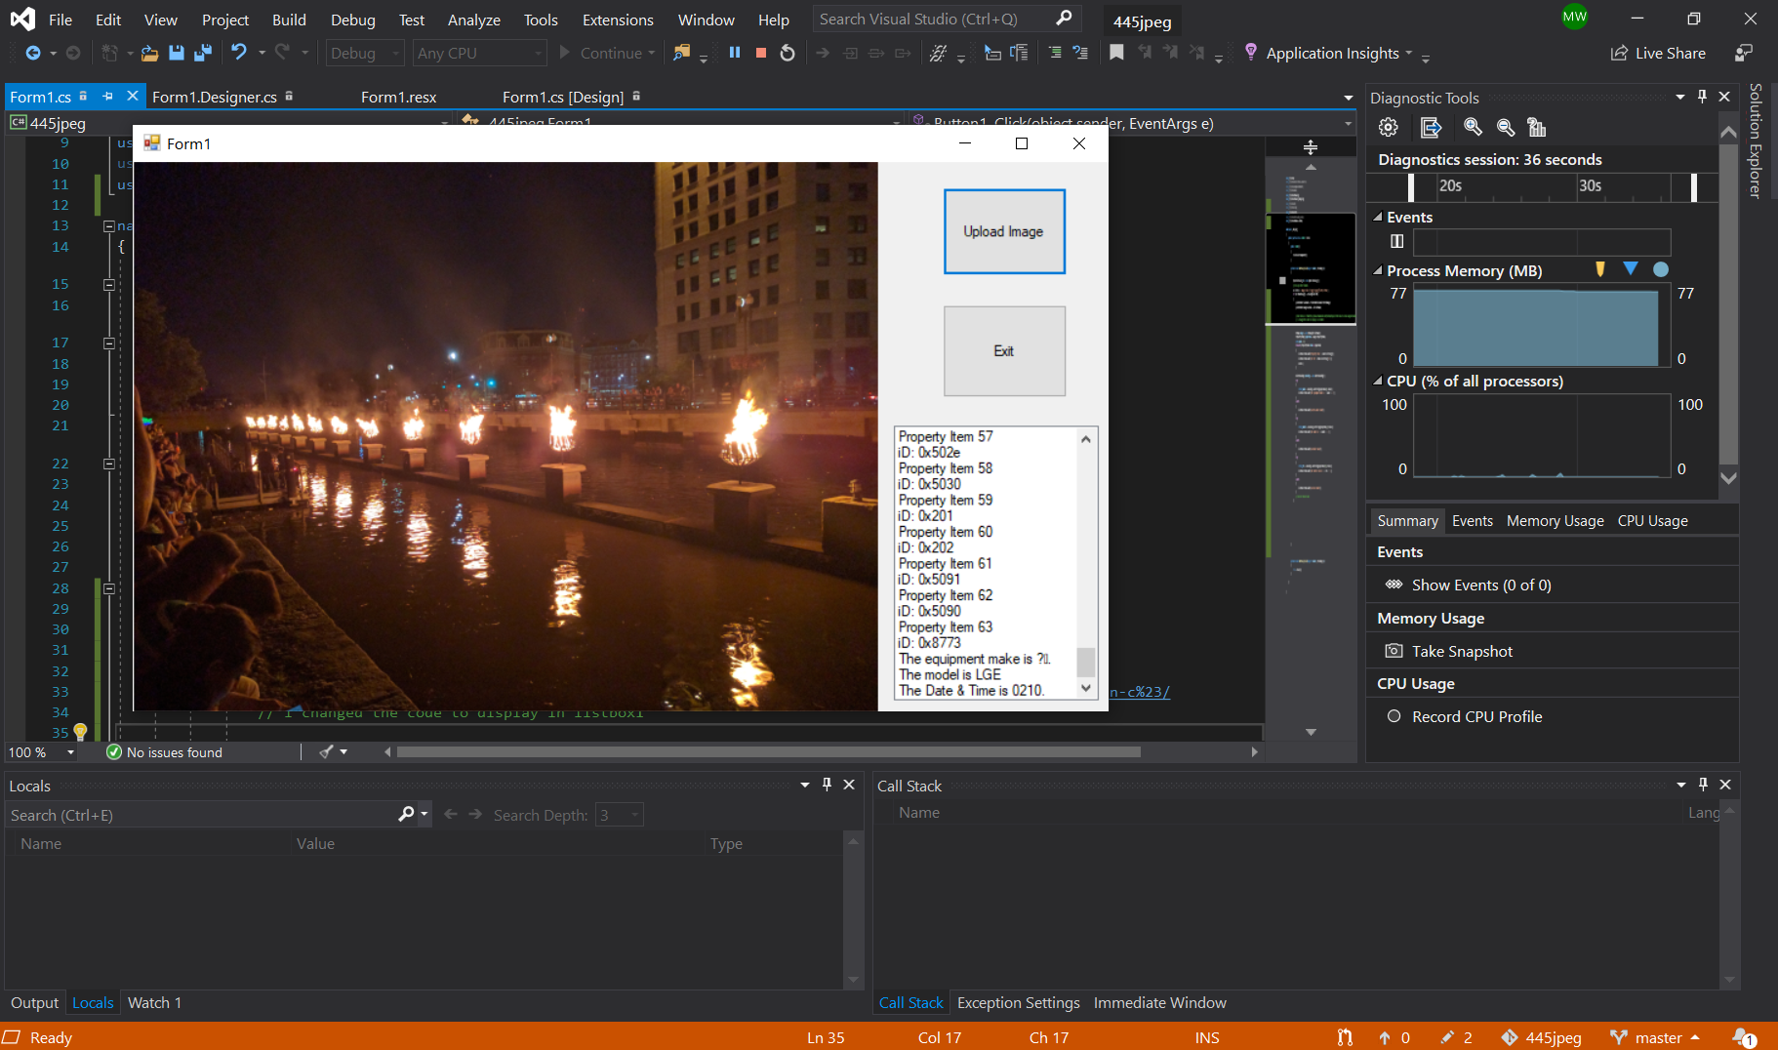

(I used one of the real images for this run)

**Program Details**

* The upload image button will let the user select an image to test and display it in the picture box (left to the upload button), and will display metadata of the image.
* The Exit button just closes the program.

**What Went Wrong**

* Expecting to be able to code in a single language.
* A Lot more work than i expected
* Needed to use java for image processing(more detailed than C#)
* Found better versions of what I was doing.
* Scaling image on the program display (Fixed)

**What Went Well**

* C# was great for making a windows program.
* Researching this problem went better than was expected.
* Learning to use different tools and programs for images.
* Found a lot of counters to my method for detecting fake images.
* Testing other programs from GitHub and C# websites (links below).
* That use of web tools can good in the right hands , but it depends on the user.

The ones that worked

<https://github.com/afsalashyana/FakeImageDetection>

This program was well made and was what I wanted to do (First part using metadata not the AI stuff ), I highly recommend looking at this project, it really helped me.

This link is what I used in the end to help me display the metadata in listbox1

<https://www.dreamincode.net/forums/topic/231165-how-to-read-image-metadata-in-c%23/>

The ones that didn’t work

<http://seecsharp.blogspot.com/2011/05/how-to-read-image-metadata-in-c.html>

This just didn’t work right for me.

Other sites used

* Stack Overflow (confusing , but had good ideas to draw from)
* <https://docs.microsoft.com/en-us/dotnet/csharp/>
* <https://docs.microsoft.com/en-us/dotnet/framework/winforms/advanced/how-to-read-image-metadata>
* <https://en.wikipedia.org/wiki/Metadata> (used for cited sources at bottom of the page)
* <https://www.youtube.com/watch?time_continue=4&v=e-cFpdqLJGE&feature=emb_title>